Name: ______________________________ Class: _________________ Date: _________________________

Weekly Spiral Review Homework #8 Due: _________________________________

Directions: Complete each problem in the space provided. SHOW ALL WORK FOR CREDIT.

- An art teacher had $\frac{2}{3}$ gallon of paint to pour containers. If he poured $\frac{1}{8}$ gallon of paint into each container until he ran out of paint. How many containers had paint in them, including the one partially filled? | - The coordinates of point F are (1,0.5) and the coordinates of point G are (-1,-0.5). Plot points F and G on the coordinate plane below.  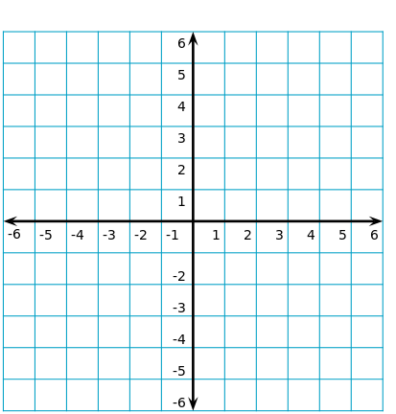
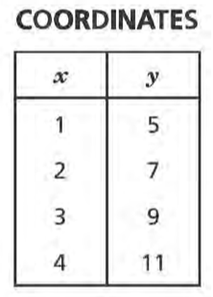  - The table below lists the coordinates of four points.  If x represents any number in the first column, write an expression that can always be used to fins the value of y in the second column. | 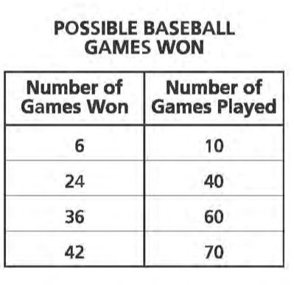  - The able below shows different possibilities for the number of games a team would need to win to maintain a certain percentage of wins.  Write three more ratios that could also be included in this table.
- The cost of 4 tacos is $6.00 at the food cart. What would be the cost of 10 tacos? | - Write an expression represented by the phrase “the square of y decreased by the quotient of 28 and 7.
- A recipe for lemonade calls for 1 cup of sugar and 5 cups of water. How much sugar is used per cup of water? | - Sam paid $8.28 for 18 stamps. At this rate, how much would it cost Sam to buy 12 stamps?
- John’s friend told him he could earn $49 for handing out flyers at a local concert. John wants to calculate the hourly rate. If he works a total of 3.5 hours, the equation $3.5x=49$ can be used to determine his hourly rate. What would John’s hourly rate be in dollars? | - Fei Yen’s dog eats 8 ounces of dog food each day. Fei Yen bought a 28-pound bag of dog food. How many 8-ounce servings are in a 28-pound bag of dog food?

