Name: ______________________________ Class: _________________ Date: _________________________

Weekly Spiral Review Homework #7 Due: _________________________________

Directions: Complete each problem in the space provided. SHOW ALL WORK FOR CREDIT.

- The points plotted on the coordinate grid below show different locations in a city. The city plans to build a parking lot at the location represented by the coordinates (8, 4). List the distance between each below.  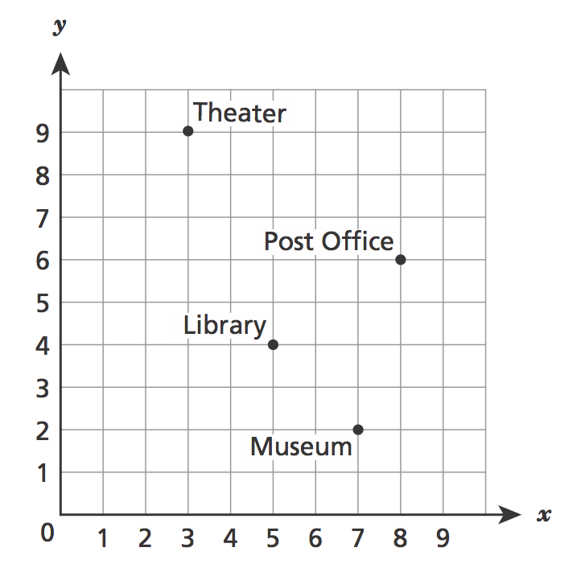  Parking Lot & Theater  Theater & Museum  Post Office & Theater  Library & Museum  Parking Lot & Museum | - A group of students organized a car wash to raise money for a local charity. The students charged $5.00 for each car they washed. In 3 hours, they washed 12 cars. At that rate, how much money could they earn from washing cars for eight hours?  Answer: $ _______________
- Kelly saves $5 every week. Write an expression that represents the amount of money, in dollars, Kelly will save in w weeks.  Expression: ________________________  Lisa spends $4 less than double the amount of money that Anna, a, spends. Write an expression for Lisa.  Expression: ________________________ | - What is the greatest common factor of 56 and 92?  Answer: __________________
- $24\frac{3}{5}+4^{3}×\left(8\frac{1}{5}-2\right)$ (use a calculator to help but show each step)  Answer: _______________ | - At a concert, 20% of the audience members were teenagers. If the number of teenagers at the concert was 360, what was the total number of audience members?  Answer: _______________audience members
- A leaky faucet is losing water and is filling a 5-gallon bucket every 20 hours. At that rate, how many gallons of water will the faucet leak in 48 hours?  Answer: _________________ gallons | - A company paid $48 for 2 cases of printer paper. Each case contained 12 packages of paper. Next month the company’s office manager needs to order 180 packages of the same paper. If the price per package does not change, what would be the total cost of next month’s order?  Answer: $ ____________________
- The volume, V, of any cube with a side length, s, can be determined using the formula $V=s^{3}$. What is the volume, in cubic centimeters, of a cube with a side length of 1.4 centimeters?  Answer: _________________ centimeters  What is a common mistake students make when working with exponents? Be sure to use the words base and exponent in your answer. | - To convert a temperature from Celsius to Fahrenheit, the temperature in Celsius is multiplied by 1.8 and then 32 is added to the product. Write an expression that can be used to convert a temperature from Celsius, c, to Fahrenheit, f, and then use that expression to convert 25 Celsius to Fahrenheit.  Expression: ___________________________  Show work here!  Answer: ________________ degrees Fahrenheit

