Name: ______________________________ Class: _________________ Date: _________________________

Weekly Spiral Review Homework #4 Due: _________________________________

Directions: Complete each problem in the space provided. SHOW ALL WORK FOR CREDIT.

- Michael had $165 to spend on teaching supplies for his classroom. He spent $48.40 on notebooks, $33.99 on markers and 24 folders which each cost 85¢. How much money does Michael have left over?  Answer: $ _________________________ | - A cupcake recipe makes a total of $5\frac{1}{3}$ cups of batter. Each cupcake uses $\frac{2}{5}$ cup of batter. How many WHOLE cupcakes will this recipe make?  Answer: ______________ cupcakes
- Find the product. You MUST show work.  $$74.15 x 5.6$$  Answer: ______________________ | - What is the greatest common factor of 45 and 60?  Answer: GCF = _______________
- A high speed elevator can rise 460 feet in 20 seconds. If the elevator travels at the same rate, how fast can it rise per minute?  Answer: _________________________ feet | - Richard’s dog eats 8 ounces of dog food each day. He bought a 28-pound bag of dog food. How many 8-ounce servings are in a 28-pound bag?  Hint: 1 pound = 16 ounces  Answer: __________________ servings
- Judie bought a new necklace. The original price was $80 and the discount was 15% off. What was the discount and sale price of the necklace?  Discount $ _____________ Sale Price $ _____________ | - Rudy travels 46 miles to Grandma’s house and then stops to get some lunch. So far he’s traveled 40% of the way there. What is the total distance, in miles, to grandma’s house?  Answer: _____________ miles
- If the coordinate ($-$1, $-$6) is reflected across the y-axis, determine the quadrant and new coordinates of the reflected image. Plot both points below.  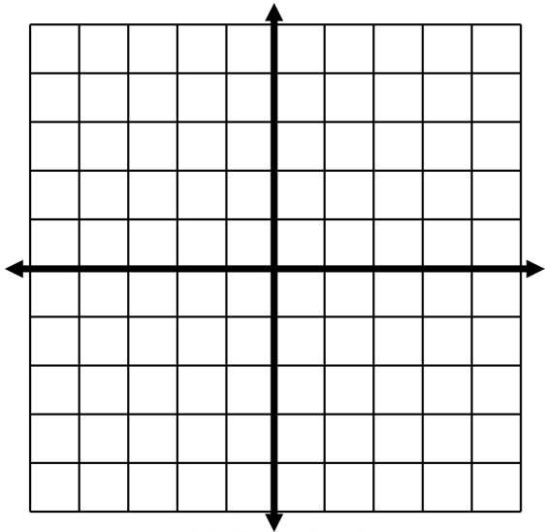  Quadrant: ___________________  Coordinates: ___________________ | 10)$4²÷ 2 + (28 ÷ 4) – 6$  Answer: __________________

