Name: ______________________________ Class: _________________ Date: _________________________

Weekly Spiral Review Homework #3 Due: _________________________________

Directions: Complete each problem in the space provided. SHOW ALL WORK FOR CREDIT.

- Carol has $1\frac{5}{8}$ cups of yogurt to make smoothies. Each smoothie uses $\frac{1}{3}$ cup of yogurt. What is the maximum number of smoothies that Carol can make with the yogurt?  Answer: ___________________ smoothies | - Evaluate: $30.51 ÷ 4.5 =$  Answer ___________________
- Machine X gets cleaned every 12 weeks. Machine Y gets cleaned every 8 weeks. What is the fewest number of weeks that will pass before both machines are cleaned in the same week?  Answer: ___________________ weeks | - Factor the following addition problems using the distributive property. SHOW WORK underneath.  $18x + 10$ $48x + 16$  _____ ( _____ + _____) _____ ( _____ + _____)
- Pat bounces a basketball 25 times in 30 seconds. At that rate, approximately how many times will Pat bounce the ball in 150 seconds?  Answer: ___________________bounces | - Jim paid $8.28 for 18 stamps. At this rate, how much would it cost Jim to buy 12 stamps?  Answer: $ ___________________
- Write as a decimal and a percent. Show your work to support your answer.  Decimal: ______________ Percent: ______________ | - At a movie, 60% of the audience members were teenagers. If the number of teenagers at the movie was 42, what was the total number of audience members?  Answer: ___________________ audience members
- Point M was located at (4, 3) and was moved to its new location of $M^{'}$(4, $-$3). Plot and label both points on the grid below. Which axis are these points reflected over?  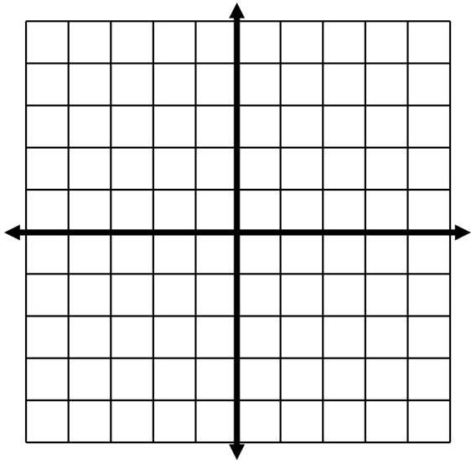  Answer: ________________________________ | 10) Plot and label point A ($-$1, 4) and point B (3, 4). Write an expression using absolute values that represents the distance, in units, between points A and B.  Answer: ________________________________

