Name: ______________________________________________ Class: _________________ Date: _______________________________

Weekly Spiral Review Homework #2 Due: _________________________________

Directions: Complete each problem in the space provided. SHOW ALL WORK FOR CREDIT.
- Omar has 2 ¾ cup of dough to make dumplings. If he uses $\frac{3}{16}$ cup of dough for each dumpling, how many whole dumplings can Omar make?  Answer: ___________________ dumplings | - The dance teacher bought a roll of ribbon that is 201.5 yards. She needs 15.5 yards of ribbon for each dancer. How many 15.5 yards pieces of ribbon can they cut from each roll of ribbon?  Answer: ___________________ pieces
- William was on a diet for 3 weeks. He lost 1.8 pounds in the first week, 3 pounds in the second week and 2.25 pounds in the third week. How much weight did he lose after the three weeks?  Answer: ___________________ pounds | - What is the least common multiple of 4, 10, and 12?  Answer: ___________________
- Abby makes chocolate milk. The ratio of milk to chocolate is 9 : 3. If she uses 15 ounces of  milk, how many ounces of chocolate should she use?  Answer: ___________________ ounces of chocolate | - Rachel babysat 2 hours each night for 10 nights. She earned a total of $180 babysitting. Rachel wants to calculate her hourly rate. How much did Rachel earn per hour babysitting?  Answer: $ ___________________
- Cosmo solved 36 of the 48 puzzles in his new puzzle book. What percent of the total number of puzzles in the book did Cosmo solve?  Answer: ___________________ %  Miguel has $40 to spend at the carnival. He went on the merry-go-round, which costs $3, the Ferris wheel, which costs $4 and the roller coaster, which costs $5. What percent of his money is remaining?  Answer: ___________________% | - All the students in the sixth grade either purchased their own lunch or brought their lunch from home on Monday.  - 24% of the students purchased lunch  - 190 students brought lunch from home  How many students are in the 6th grade?  Answer: ___________________ students
- The table below shows the low temperatures in Harrisburg, Pennsylvania each day for four days. Write the DAYS in order from least to greatest.  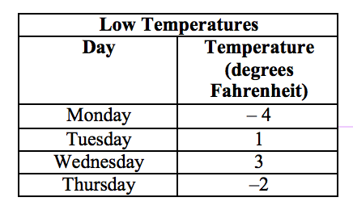  ______________________________, ______________________________,  ______________________________, ______________________________  If Friday was the COLDEST day, write any value that could represent the temperature.  Answer: ___________________ $℉$ | 10) Plot each rational number on the number line below and label each with the corresponding letter for each point.  Point A $-3.5$  Point B  Point C $-1\frac{1}{2}$  Point D $-$3  Point E

