Name: ______________________________ Class: _________________ Date: _________________________

Weekly Spiral Review Homework #10 Due: _________________________________

Directions: Complete each problem in the space provided. SHOW ALL WORK FOR CREDIT.

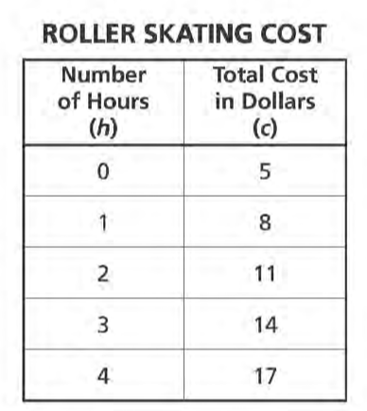  - The Frenchtown Roller Rink chargers $5 entrance fee and an hourly rate for roller skating. The total cost for roller skating depends on the number of hours a person skates. The table below represents the total cost of skating for different numbers of hours.  Write an equation to represent the relationship between the cost, c, and the number of hours, h. | - Bronson is using a coordinate plane to design a rectangular swimming pool. He will plot points on the coordinate plane to mark the vertices of a rectangular pool bottom. If Bronson plots the first three points at (5,3), (5,13) and (30,13), what would be the coordinates of the fourth point?
- Chakan worked at the warehouse after school. He earned $9.25 per hour stacking boxes. Write an equation that relates Chakan’s total earnings, d, to the number of hours he worked, h? | - Residents of a small city voted on whether to allow a developer to build a shopping center. The number of votes in favor of the shopping center was 4,400. The number of votes against the shopping center was 17,600. What percent of the voters were in favor of building the shopping center?
- Zelma buys p pounds of bananas for 40 cents per pound. She pays the clerk with a twenty-dollar bill. The clerk subtracts the total cost of the bananas from the twenty-dollar bill to determine the amount of change to give Zelma. Write an expression to represent the amount of change Zelma should receive. | - A scientist studied the migration of two types of whales.  - The humpback whales traveled 2,240 miles in 28 days  - The gray whales traveled 2,368 miles in 32 days  If the humpback whales had traveled at the same rate for 32 days, how many more miles would they have traveled than the gray whales?
- Expressions A, B, and C are shown below.  A B C  ${20}^{2}-{18}^{2}$ ${8(4}^{2})+2^{4}$ ${15}^{2}-3^{4}$  Which expression or expressions have the same value as ${12}^{2}$? | - Darnell’s car used 8 gallons of gas to travel 340 miles. After a mechanic worked on it, it used 7 gallons to travel 350 miles. If the price of gas was $4.00 per gallon, how much less, to the nearest cent per mile, did it cost to run the car after it was fixed?
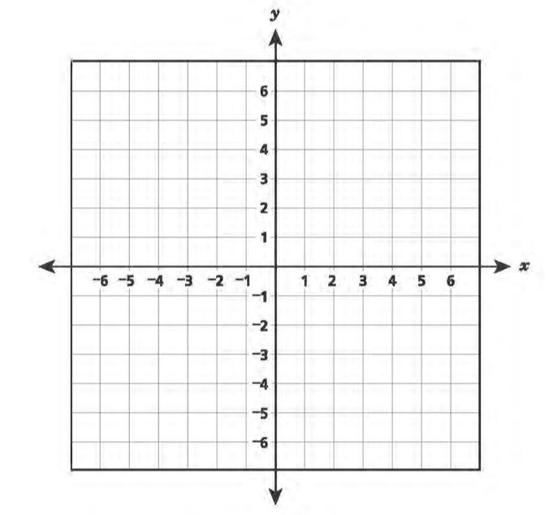  - The coordinate grid below represents a town. Curtis’s house is at (-4,-6) and Jean’s house is at (-4,3). Plot the points where Curtis’s house and Jean’s house are located.  Each unit on the grid represents 1 mile. If Curtis can ride his bike at a constant rate of 12 miles per hour, how many minutes would it take Curtis to ride from his house to Jean’s house? | - A carpenter built three bookcases, A, B, and C, to stand next to each other along a wall. The total length of the wall is 456 centimeters. The carpenter will build two more bookcases, D, and E, along the same wall. These two bookcases will have equal widths. The widths of bookcases A, B, and C are shown in the table below.  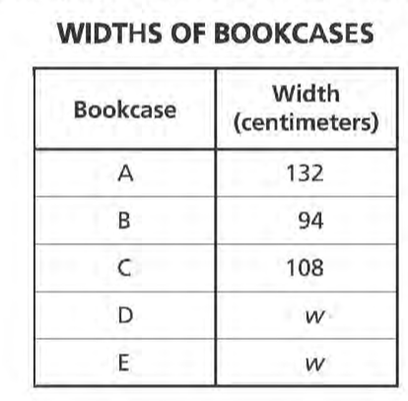  Write and solve an equation to determine w, the greatest possible width for bookcases D and E.

