Name ____________________________________________ Class ______________ Date ________________________
Volume Homework

Example 1- The pool at the London Aquatics Center has the dimensions of the figure below. The pool is drained and refilled every night. What volume of water would be required to fill the pool to the rim?
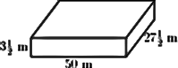
Example 2- Find the volume.
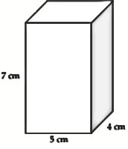
Example 3- Zoe made rice crispy treats in a 9 x 13 x 12 inch cake pan. | (a) What is the total volume of rice crispy treats?  (b) How many 12 in. x 12 in. rice crispy treats could be cut from the pan?

Review Questions:
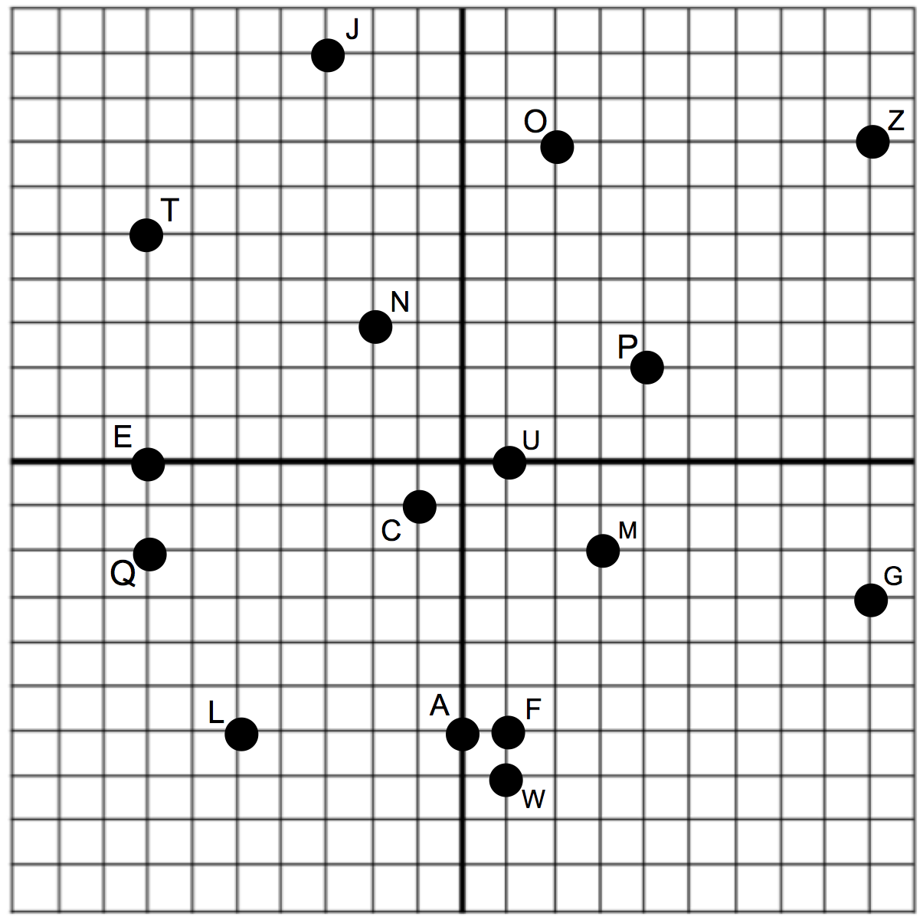
Write the ordered pair for each
given point.
L __________________
O __________________
C __________________
E __________________
M __________________
Q __________________
N __________________
F __________________
What point is located at each point?
(-7, 5) __________
(0, -6) __________
(4, 2) __________
(1, -7) __________
(9, -3) __________
(1, 0) __________
(-3, 9) __________
(9, 7) __________

