NAME: _______________________________________ CLASS: _____________ DATE: __________________________
Lesson #5 – Surface Area and Nets Day 2 Homework

1. What is the name of the shape below?____________________
How many faces does it have?_____________________________
Draw the net for the figure below and determine its surface area in centimeters.
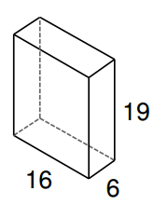
cm
cm
cm

2. What is the name of the shape below?____________________
How many faces does it have?_____________________________
Draw the net for the figure below and determine its surface area in inches.
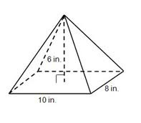

3. What is the name of the shape below?____________________
How many faces does it have?_____________________________
Draw the net for the figure below and determine its surface area.
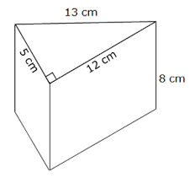

Review Prior Knowledge

Directions: Write an equation to represent the situations below
4) John has J CDs. Dianne has 2 more than 4 times as many CDs. How many CDs does Dianne, D, have?

Write an equation: ____________________

5) Kate’s 85 on her English test was 37 points less than twice the grade on her Science test, S.

Write an equation: ____________________

6) Lawrence bought a package of 6 spiral notebooks for a total cost of $13.50. Write and equation that represents p, the cost in dollars, of each notebook?
Write an equation: _____________________

7) The 347 students who listed soccer as their favorite sport were 13 less than three times the number of students who listed basketball as their favorite sport.
Write an equation: ____________________

Directions: Write an inequality to represent the situations below.
8) Kelsey needs to make at most 20 cupcakes to have enough for her party.

Write an inequality: ____________________

9) Anyone with a temperature greater than 98.6 degrees Fahrenheit has a fever.

Write an inequality: ____________________

10) An electrician can only use wire that is less than one-eighth of an inch.

Write an inequality: ____________________

11) To win in the Hot Dog eating contest, Joey must eat at least 86 hot dogs.

Write an inequality: ____________________

