Name __________________________________________ Class ________________ Date __________________________________
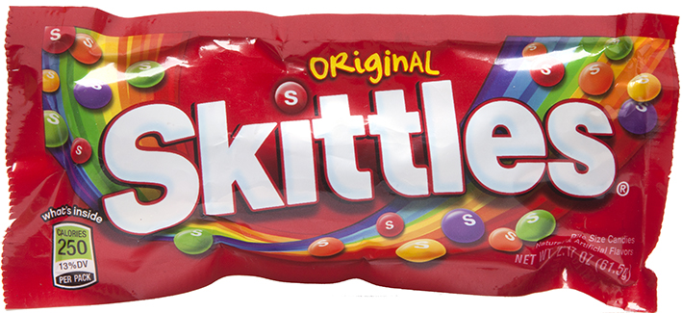
Skittle Activity

Directions: Open your bag of skittles on the paper towel. Please DO NOT drop any on the floor. Sort the skittles by color and record the number in the corresponding box.

Red | Orange | Yellow | Green | Purple

Create a dot plot of the data.

Red Orange Yellow Green Blue

Using the numbers in the box above, write your data set: __________, __________, __________, __________, __________
Using those 5 numbers, find the following: SHOW ALL WORK

Mean: __________________
Median: __________________
Mode: __________________
Range: __________________

Now, combine your data set with another person and record the data below:

__________, __________, __________, __________, __________, __________, __________, __________, __________, __________

Put the numbers in order and find the following: mean, median, mode, range, min, max, Q1, Q3, and IQR.
SHOW ALL WORK

Make a box and whisker plot and label the five number summary. Be sure to create an appropriate scale.

Take your data only and fill in the following chart. Simplify your fractions. Use the calculator to help.

Color | Amount | Fraction | Decimal | Percent
Red
Orange
Yellow
Green
Purple

What color are you most likely to take out of the bag? ________________________________

What color are you least likely to take out of the bag? ________________________________

Use the students in your group to fill out the following table. SHOW ALL WORK in the space below.

Table Data |  |  |  |  |  |  | For each color, find…
Student Initials | Your data |  |  |  |  |  | Mean | Median | Mode
Red
Orange
Yellow
Green
Purple
Total #

