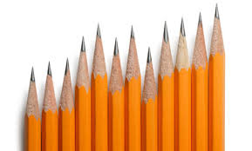Math 6th Grade Supply List

* 1 marble **graph** **notebook**
* 1 pack of pencils
* 1 pack of loose leaf
* 1 pack of graph paper (quarter inch)
* 1 pack of 5x8 index cards
* 1 pack of washable markers (8 different colors)
* 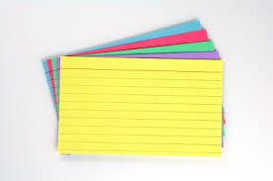1 ruler
* 1 pencil sharpener
* 1 eraser

