Name _____________________________________________________ Class _______________ Date ________________________________

Area of Irregular Figures HW

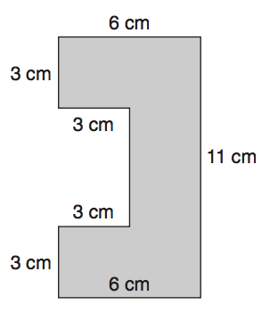Directions: Show all work to determine the area of each figure below.

