Name __________________________________________________ Class _____________ Date ____________________________________
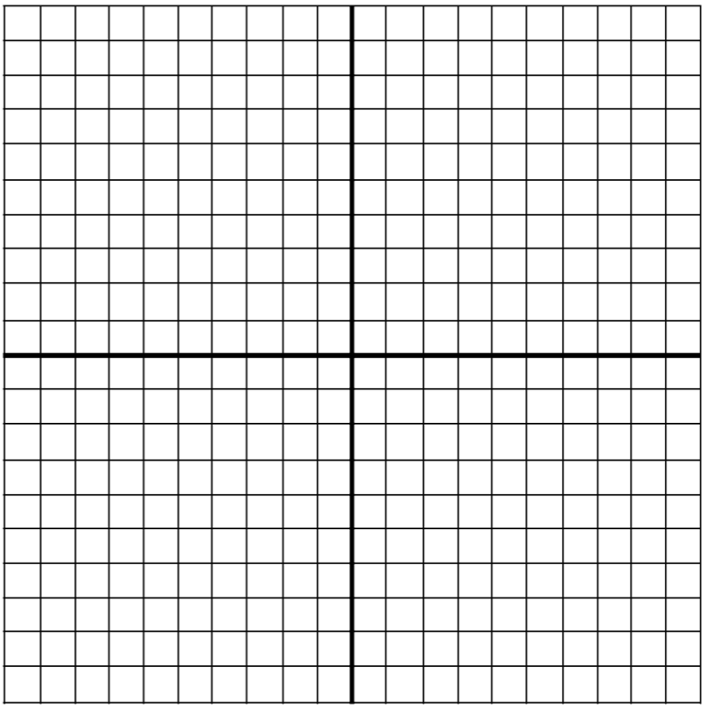
Lesson #8 – Graphing Homework

- Plot and label each of the points below. After, list what quadrant or axis each point is located in.
  - (4, 6) ____________________
  - (-2, 0) ____________________
  - (1, -5) ____________________
  - (2, 0) ____________________
  - (4, -6) ____________________
  - (-8, -3) ____________________
  - (0, 3) ____________________

- Which two pairs of points have the same absolute value? ____________________ and ____________________
- Which point has the same absolute value as point E?
______________________________
- If I reflect point G over the x-axis, what would the new
point be? ________________________

Review Questions
- Put the following number in order from GREATEST to LEAST.
$$\frac{3}{5} -\left|-7\right| 1.25 4 3\frac{1}{4} \left|6\right| -3.5$$

- Complete the ratio table below.

8 | 12 | 18 | 24 |  |  |  | 100 | 120
12 |  |  |  | 42 | 60 | 84 |  |  | 210

