Name __________________________________________________ Class ______________ Date ___________________________________
Lesson #7 – Graphing Homework
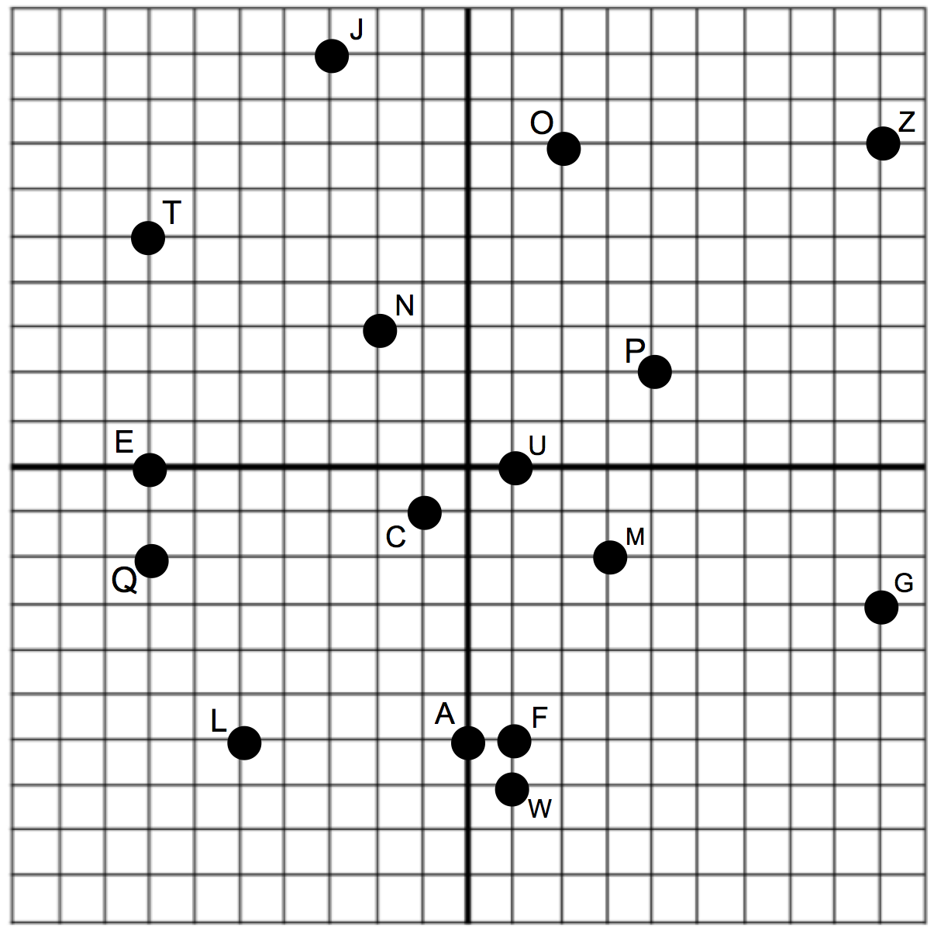
- Tell what point is located at each ordered pair.
(-7, 5) __________
(0, -6) __________
(4, 2) __________
(1, -7) __________
(9, -3) __________
(1, 0) __________
(-3, 9) __________
(9, 7) __________
- Write the ordered pair for each given point.
L __________________
O __________________
C __________________
E __________________
3. Plot the following points on the coordinate grid and write what quadrant it belongs in.

Quadrant
S (-4, 5)
D (-9, -5)
B (-5, 9)
K (8, -9)
R (-3, 5)
V (5, 2)
X (-9, 4)
Y (4, -4)

M __________________
Q __________________
N __________________
F __________________

Review:
$\frac{3}{6}+\frac{2}{9}=$ $2\frac{5}{6} × 1\frac{3}{4}=$ $4\frac{3}{5}÷7$ $1\frac{2}{3}-\frac{4}{7}$

