Name _________________________________________________________ Class _________________ Date _____________________________________
Lesson #1 – Exponents HW
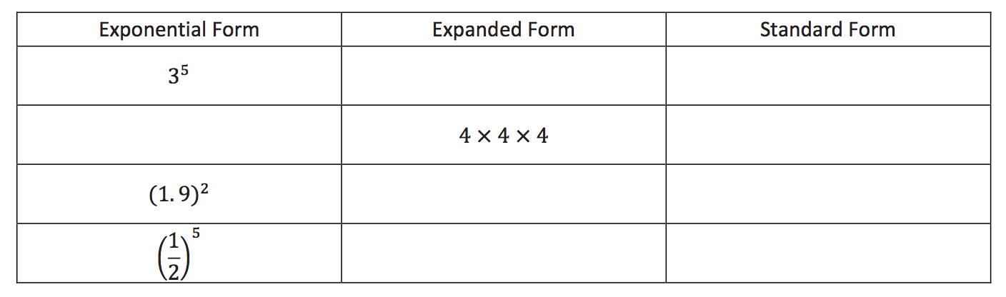
1)

2) Write “seven cubed” in all three forms (exponential form, expanded form, and standard form.)
3) Evaluate the following expressions:
$${(\frac{2}{3})}^{3}$$ | $$1^{66}$$ | $${(\frac{7}{8})}^{2}$$
$${7.9649}^{0}$$ | $$0^{1764}$$ | $${0.2}^{3}$$

Review Questions:

4) Find the area and perimeter of the shape below.

5)
Decimal | Fraction | Percent
.03

 | $$\frac{1}{5}$$
 |  | 36%

