Name ______________________________________ Class ________________ Date _____________________________
Lesson #2 – Area of a Triangle and Trapezoid Homework

- If the base is $3.4 in$ and the height is 2.8in, what is the area of the triangle?
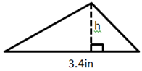

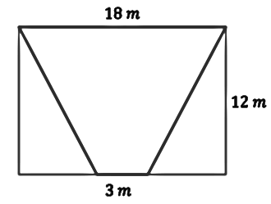
- Determine the area of the trapezoid below.

- Find the area of the triangle below.
$$17.4 cm$$
$$12 cm$$
$$15 cm$$
$$9 cm$$
$$12.6 cm$$

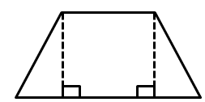
- Find the area of the trapezoid below
$$5 ft.$$
$$12 ft.$$
$13$ ft.
$12$ ft.
$$5 ft.$$

Review Prior Knowledge
Plot each value as a fraction or decimal on a number line. *USE THE CORRECT AMOUNT OF TICK MARKS!*
- Plot 5.4
It’s between _____ and _____

- Plot $-\frac{1}{4}$
It’s between _____ and _____

- Plot -1.9
It’s between _____ and _____

- Plot $3\frac{2}{5}$
It’s between _____ and _____

