Name_______________________________________________________ Class_____________ Date_____________________________________________
Area of a Parallelogram and Rectangle Homework

Directions: Find the area of each shape below.

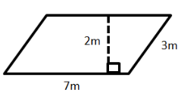
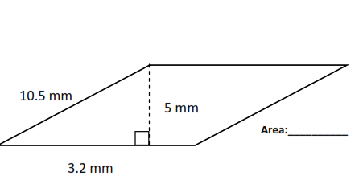

MIXED REVIEW

- 5.012 + 23.1 + 3001 | - 4.01 x 3.2
- 1.44 ÷ 1.2 | - What is the Least Common Multiple between 6 and 8
- What is the Greatest Common Factor of 96 and 16 | - Write an equivalent expression for 5x + 30x²

