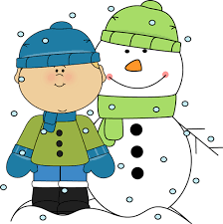
6th Grade

Winter Packet
Name:________________ Class: ___________
I.S.73 Date: ___________
To be completed anytime from December 24. 2015 – January 3, 2016
Return to your math teacher on _____________________.

Part 1: Multiple Choice
- (6NS1) What is the value of the expression 3.41 x 0.2?

- 0.682
- 6.82
- 68.2
- 682

- (6RP3a) The table shows the amounts, in gallons, of blue paint and yellow paint that are mixed to form a shade of green paint.
Amount of Blue Paint (in gallons) | Amount of Yellow Paint (in gallons)
6 | 10
9 | 15
? | 25
18 | 30
How many gallons of blue paint should be mixed with 25 gallons of yellow paint to form the same shade of green?

- 12
- 14
- 15
- 17

- (6NS1) What is the value of the expression $2\frac{3}{4}$ ÷ $\frac{5}{8}$ ?

- $\frac{32}{55}$
- $1\frac{23}{32}$
- $3\frac{1}{5}$
- $4\frac{2}{5}$

- (6RP3c) A fruit salad has 18 red apples. This is 40% of the total apples in the stand. How many apples are there in the stand?

- 22
- 30
- 45
- 58

- (6RP3) The cost of 4 tacos is $6.00 at the food cart. What would be the cost of 10 tacos at this food cart?

- $11.50
- $15.00
- $36.00
- $60.00

- (6NS4) Which pair of numbers has the same Greatest Common Factor as that of 48 and 78?

- 4 and 34
- 8 and 18
- 9 and 15
- 12 and 30

- (6RP3d) Using the conversion box below, find how many quarts are in 384 ounces.
Measurement
1 quart = 4 cups
1 cup = 8 ounces
]

- $\frac{1}{32}$
- $\frac{1}{12}$

- 12
- 32

- (6RP2) A truck delivered 80 tons of bricks in 4 hours. The truck delivered an equal amount of bricks each hour. How many bricks did the truck driver deliver per hour?

- $\frac{1}{20}$ton per hour
- $\frac{1}{4}$ton per hour

- $4$ tons per hour
- $20$ tons per hour

- (6RP1) A store sells pencils and erasers in packs. The table shows the number of pencils and erasers in different numbers of packs.

Packs | Pencils | Erasers
2 | 10 | 6
3 | 15 | 9
4 | 20 | 12

Which statement describes both the ratio of the number of packs to the number of pencils and the number of packs to the number of erasers?

- The ratio of packs to pencils is 1:5, and the ratio of packs to erasers is 1:3
- The ratio of packs to pencils is 5:3, and the ratio of packs to erasers is 3:5
- The ratio of packs to pencils is 2:3, and the ratio of packs to erasers is 2:3
- The ratio of packs to pencils is 1:3, and the ratio of packs to erasers is 1:5

- (6NS4) What is the least common multiple of 8 and 12?

- 4
- 20
- 24
- 96

Part 2: Short Response. Show all work.
- Maria plans to fill the posts in her garden with soil and plant food. Maria has 8$\frac{1}{4}$quarts of soil and 1$\frac{1}{2}$ quarts of plant food.

- (6NS1) Each pot requires $\frac{3}{4}$quart of soil. How many pots can Maria fill with soil?
Show your work.

Answer: ________________

- (6NS1) Each pot requires $\frac{1}{3}$quart of plant food. How many pots can Maria fill with plant food?
Show your work.

Answer: ________________

- Each pot that Maria creates must have both soil and plant food. How many points can Maria fill completely with the required amount of both soil and plant food? Explain your answer below:
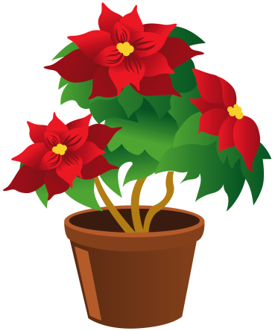
____________________________________________________________________________________________________________________________________________________________________________________________________________________________________________________________

- This model below shows the number of cups of sugar and flower in a recipe for a cake.
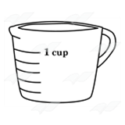
Sugar

Flour
- (6RP2) Harry wanted to bake a small cake, so he only uses 1 cup of sugar. Based on the recipe, how many cups of flour should he use? Show your work.

Answer: ________________ cups

- (6RP3) A baker wants to bake a large cake, so he uses 15 cups of flour. Based on the recipe, how many cups of sugar should the baker use? Show your work.

Answer: ________________ cups

- Jordan wants to double the recipe for the cake. He said he should use 4 cups of sugar and 7 cups of flour. Is Jordan correct or incorrect? Explain why or why not.__________________________________ ____________________________________________________________________________________
____________________________________________________________________________________

